

**Aircraft Management**

**A CAPSTONE PROJECT REPORT**

**Submitted to**

**SAVEETHA SCHOOL OF ENGINEERING**

**CSA1243-COMPUTER ARCHITECTURE**

**BY**

**K.LAKSHΜΑΝ**

**(192110090)**

**V.SURESH**

**(192112045)**

**V.TARAK RAM**

**(192110545)**

**Supervisor**

**Mrs. SARANNIYA S**

**SIMATS ENGINEERING**

**SAVEETHA INSTITUTE OF MEDICAL AND**

**TECHNICAL SCIENCES**

**CHENNAI-602 105**

**FEB-2024**

**ABSTRACT:**

Aircraft management encompasses the broad spectrum of tasks involved in ensuring the safe, efficient, and airworthy operation of an aircraft. It covers a range of activities from maintenance scheduling and logistics to crew management and flight operations.

An effective aircraft management system is crucial for airlines, private jet owners, and any entity operating aircraft. It helps to:

* **Maintain safety:** By ensuring proper maintenance is performed and regulations are adhered to.
* **Optimize operations:** Through efficient scheduling, resource allocation, and cost control.
* **Enhance efficiency:** By streamlining processes and minimizing downtime.
* **Improve profitability:** Through cost reduction and efficient utilization of aircraft.

This abstract provides a high-level overview of aircraft management. Specific aspects within this domain, such as maintenance planning or flight operations, can be further explored depending on your interest.

**INTRODUCTION:**

Imagine owning a complex, multi-million dollar machine. Now imagine needing to keep it in peak condition, ready to fly at a moment's notice, while adhering to strict safety regulations and maximizing its usefulness. That's the world of aircraft management.

Aircraft management is all about ensuring the smooth, safe, and cost-effective operation of an aircraft. It's a multifaceted field that caters to airlines with massive fleets and private individuals with a single jet. Regardless of the scale, the core principles remain the same: keeping the aircraft airworthy, optimizing its use, and mitigating risks.

This introduction dives into the why and how of aircraft management. We'll explore the key areas it covers, from maintenance scheduling to crew management, and highlight the benefits it brings to aircraft owners and operators. By the end, you'll gain a solid understanding of this crucial aspect of the aviation industry.

**GANTT CHART:**

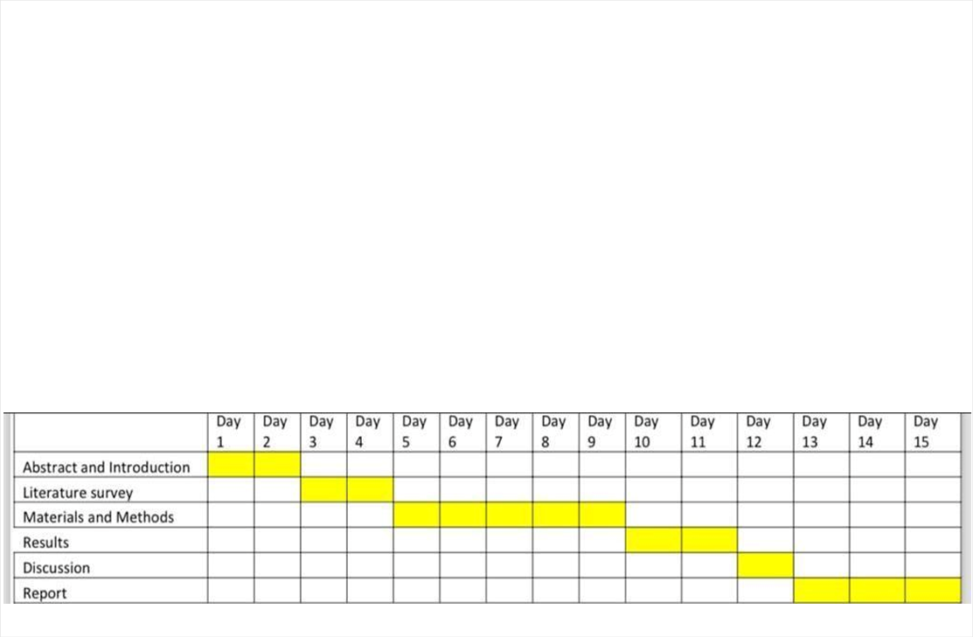

**LITERATURE**:

The world of aircraft management demands knowledge from various sources. Here's a breakdown of the literature you might encounter:

**Regulatory Resources:**

* **Federal Aviation Regulations (FARs):** Published by the FAA (Federal Aviation Administration) in the US, these regulations govern all aspects of civil aviation, including aircraft maintenance and operation. International equivalents exist, such as EASA regulations in Europe.

**Textbooks and Academic Publications:**

* **Introduction to Aviation Management:** This type of textbook provides a broad overview of the aviation industry, including aircraft management principles.
* **Aviation Maintenance Management:** These delve deeper into the technical aspects of maintaining aircraft, crucial for ensuring airworthiness.
* **Research papers:** Published in academic journals, these explore specific aspects of aircraft management, like optimizing scheduling or safety risk management. You can find them through academic databases or university websites.
* **A classification and literature survey on aviation management:** This type of paper offers a curated overview of existing research in the field, helping you identify relevant academic sources [consider mentioning this specific paper as an example].

**Industry Publications and Online Resources:**

* **Aircraft Owners and Pilots Association (AOPA):** This organization offers resources and publications for private aircraft owners, including information on aircraft management best practices. Similar organizations exist for other regions.
* **Manufacturer Manuals:** Aircraft manufacturers publish detailed manuals outlining maintenance procedures and operational limitations specific to each aircraft model.
* **Industry Magazines and Websites:** Publications like Aviation Week & Space Technology or Flight global offer articles and insights on current trends and best practices in aircraft management.

**Additional Resources:**

* **Online Courses:** Universities and professional organizations offer online courses on aircraft management, providing a structured learning experience.
* **Conferences and Events:** Attending industry conferences can connect you with professionals and access the latest information on aircraft management practices.

Remember, the specific literature you delve into will depend on your focus within aircraft management.

**DESIGN**:

Aircraft management systems (AMS) can be designed from various angles depending on the specific needs of the operator. Here's a breakdown of key design considerations:

**Functionality:**

* **Core functionalities:**
  + **Maintenance Management:**
    - Track maintenance schedules and parts inventory.
    - Schedule and manage maintenance tasks.
    - Record maintenance history for airworthiness compliance.
  + **Flight Operations Management:**
    - Flight scheduling and dispatch.
    - Crew management and assignment.
    - Flight tracking and monitoring.
    - Fuel management and optimization.
  + **Document Management:**
    - Store and manage aircraft manuals, certifications, and regulatory documents.
    - Facilitate document control and versioning.
* **Advanced functionalities:**
  + **Predictive Maintenance:** Analyse data to predict potential maintenance issues and schedule interventions before they become critical.
  + **Business Intelligence and Reporting:** Generate reports on aircraft utilization, maintenance costs, and operational efficiency.
  + **Compliance Management:** Track regulatory changes and ensure adherence to aviation safety standards.

**User Interface (UI) and User Experience (UX):**

* **Intuitive and user-friendly interface:** Easy navigation and data visualization for efficient information access.
* **Role-based access control:** Grant specific permissions to different user types (maintenance personnel, pilots, etc.)
* **Mobile access:** Enable access to key functionalities on mobile devices for on-the-go management.

**Data Security:**

* **Secure data storage:** Protect sensitive aircraft and operational data with robust security measures.
* **Access control:** Implement access controls to prevent unauthorized data modification.
* **Backup and disaster recovery plan:** Ensure data integrity and system availability in case of disruptions.

**Scalability and Integration:**

* **Scalable to accommodate growth:** The system should adapt to an increasing number of aircraft or users.
* **Integration with other systems:** Integrate with accounting software, flight planning tools, or weather data platforms for a more holistic view.

**Additional Design Considerations:**

* **Cost-effectiveness:** The chosen AMS solution should offer value for money, considering implementation and maintenance costs.
* **Regulatory compliance:** Ensure the system adheres to relevant aviation regulations and industry standards.
* **Customization:** The system should be adaptable to specific needs and workflows of the operator.

**Here are some design approaches to consider:**

* **Modular design:** Break down the system into modules for easier development, maintenance, and customization.
* **Cloud-based solution:** Leverage cloud computing for scalability, accessibility, and data security.
* **Open-source platforms:** Explore open-source AMS solutions for cost-effectiveness and customization potential.

Remember, the optimal design will depend on the specific needs of the aircraft operator. By carefully considering these factors, you can create an aircraft management system that ensures safety, efficiency, and profitability.

**ANALYSIS**:

Aircraft management systems (AMS) play a critical role in the aviation industry, impacting safety, efficiency, and profitability. Here's an analysis of AMS from various perspectives:

**Benefits:**

* **Enhanced Safety:**
  + Improved maintenance tracking reduces the risk of in-flight failures.
  + Streamlined data management ensures access to critical operational information.
  + Automated tasks and alerts minimize human error.
* **Increased Efficiency:**
  + Optimized scheduling minimizes downtime and maximizes aircraft utilization.
  + Real-time data analysis allows for better decision-making and resource allocation.
  + Streamlined communication improves collaboration between departments.
* **Cost Reduction:**
  + Predictive maintenance prevents unnecessary repairs and extends component lifespan.
  + Improved fuel management practices minimize fuel consumption.
  + Data-driven decision-making helps optimize resource allocation and reduce operational costs.
* **Improved Regulatory Compliance:**
  + Automated tracking of maintenance records and documentation simplifies compliance audits.
  + Regulatory updates and alerts ensure adherence to evolving aviation standards.
  + Streamlined data management improves transparency and facilitates collaboration with regulatory bodies.

**Challenges:**

* **Implementation Costs:**
  + Initial investment in software, hardware, and system integration can be significant.
  + Training personnel on the new system adds to the overall cost.
* **Data Security Concerns:**
  + AMS stores sensitive aircraft and operational data, making it a target for cyberattacks.
  + Robust security measures are essential to prevent data breaches and ensure system integrity.
* **System Complexity:**
  + Complex AMS features might require extensive training for users to become proficient.
  + User-friendly interfaces and intuitive design are crucial for maximizing system adoption and effectiveness.
* **Data Integration:**
  + Integrating AMS with existing systems (accounting, flight planning) can be a challenge.
  + Data standardization and compatibility are essential for seamless information flow across different platforms.

**Future Trends:**

* **Artificial Intelligence (AI) and Machine Learning (ML):**
  + Predictive maintenance will become more sophisticated with AI and ML, further enhancing safety and reducing costs.
  + AI-powered data analysis can provide deeper insights for optimizing operations and resource allocation.
* **Cloud-based Solutions:**
  + Cloud computing will continue to revolutionize AMS, offering scalability, accessibility, and cost-effectiveness.
  + Cloud-based systems enable real-time data access and collaboration from anywhere.
* **Cybersecurity Enhancements:**
  + As AMS become more interconnected, robust cybersecurity measures will be paramount.
  + Advanced data encryption and access controls will be crucial for protecting sensitive information.
* **Focus on Sustainability:**
  + AMS will integrate features that promote sustainable aviation practices.
  + Optimizing fuel efficiency and reducing environmental impact will be a growing focus.

By understanding the benefits, challenges, and future trends of aircraft management systems, stakeholders can make informed decisions about implementation, utilization, and continuous improvement. An effective AMS can be a game-changer for any aircraft operator, ensuring a safe, efficient, and profitable aviation experience.

**CONCLUSION:**

Aircraft management is a multifaceted discipline that ensures the smooth, safe, and cost-effective operation of aircraft. Effective aircraft management systems (AMS) are crucial for airlines, private jet owners, and any entity operating aircraft.

**Key Takeaways:**

* **Safety First:** AMS prioritizes safety by ensuring proper maintenance, regulatory compliance, and minimizing human error.
* **Efficiency Matters:** Through optimized scheduling, streamlined processes, and data-driven decision-making, AMS enhances operational efficiency.
* **Cost Control:** Predictive maintenance, resource allocation optimization, and fuel management practices implemented through AMS lead to cost reduction.
* **Technology Drives Progress:** Advancements in AI, cloud computing, and data security will shape the future of AMS, further enhancing its capabilities.

**Looking Forward:**

The future of aircraft management lies in leveraging technology to its fullest potential. Advanced analytics, predictive maintenance, and AI-powered optimization will continue to revolutionize this field. By embracing these advancements and remaining focused on safety, efficiency, and sustainability, aircraft management systems will remain a cornerstone of aviation success.